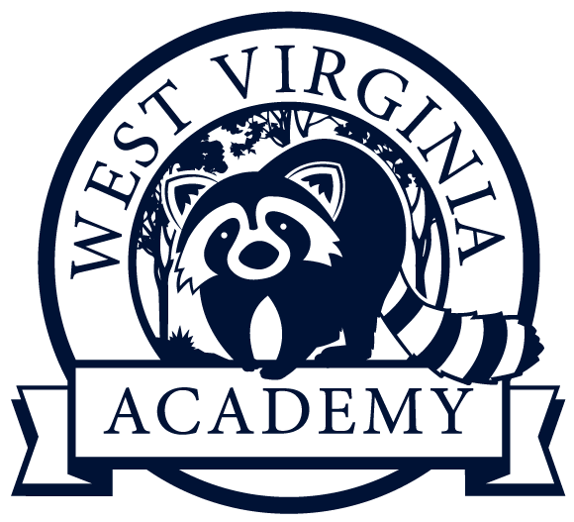
West Virginia Academy, Ltd.
Governing Board Meeting Minutes
June 16, 2022 | 7:00pm (EST)

I. Approve minutes from prior meeting
II. General Updates
III. Approval for Bridge Loan & Financing
IV. Approval of Various Policies including: (i) updated employee handbook, (ii) PTO Policy, (iii) FMLA Policy, and (iv) Competitive Sports Policies
V. Proposal and Approval for Short Fiscal/Tax Year for 2021-2022 to adjust YE to June 30th
VI. New Items and Other Business

